Yorkshire & Humber Action Card - Healthier & Resilient Food Systems
Green Spaces & Urban Growing
The Office for Health Improvement and Disparities, Yorkshire and Humber team are working on a series of topic-based action cards focused on the Healthier and Resilient Food Systems workstream.
The action cards are aimed at local authorities, food partnerships, Integrated Care Systems and other food organisations and stakeholders working within the local food system. In producing the action cards, we aim to bring together concise and relevant information on a number of key joint objectives across the food system, to guide and support stakeholders in making the case and progressing work with local partners.

Background
Spending time outside in nature, growing food with other people within the local community can have many positive benefits to people’s health and wellbeing, their local environment, and wider impacts such as climate change and air quality. Community food growing can improve mental and physical health, reduce loneliness and social isolation and increase people’s sense of belonging, confidence and self-esteem.

Growing food within the local community helps to inspire and educate people on growing local seasonal food, which in turn may encourage more healthy eating and cooking in the home with freshly grown ingredients, reducing the consumption of processed foods which are not only worse for health but also the environment. Having access to locally grown food may also help with food security. Community food growing can have a positive impact on climate change by reducing food miles and improving air quality and help create healthier environments by attracting wildlife with plants and increasing local biodiversity.

It is well known that green spaces within the community are associated with better mental health for everyone across the life course. Community gardens can enhance the look and image of the local environment, especially in more deprived areas. Growing food as part of a group, supports community cohesion and inclusion helping to create healthier communities.

Key Facts
Public Health England identified allotments and community gardens as green infrastructure in the Improving Access to Green Space: A new review for 2020 document.
The review suggests the following ways in which greenspace may be linked to positive health outcomes:

- Promotes healthy behaviours
- Improves social contacts/gives people a sense of familiarity and belonging
- Supports the development of skills and capabilities
- Mediates potential harm

Establishing interventions, such as green social prescribing initiatives may encourage and support people who do not currently use greenspaces to begin using them. Programmes to support social engagement or to facilitate participation in activities coupled with improvements to the physical environment, are an effective approach to enable people to start using these spaces and to continue to use them.

In December 2020, seven sites in England were awarded funding to test the ways in which connecting people with nature can improve mental wellbeing. Each site will explore and bring together opportunities for communities to get involved in their natural environment. Including activities such as walking, cycling, community gardening and food-growing projects, and practical conservation tasks such as tree planting. Two of the sites chosen are in the Yorkshire and Humber Region; Humber Coast and Vale Integrated Care System and South Yorkshire and Bassetlaw Integrated Care System.

The amount of green space available to people differs depending on local deprivation. In areas with higher levels of deprivation there tends to be less green space available compared to less deprived areas. A report published by community charity Groundwork finds severe inequalities in access to parks and greenspaces in communities across the UK.

Key statistics brought together in the report show that:

- Only 5% of adults say that access to nature has never been important to them or their mental health
- 40% of people from ethnic minority backgrounds live in the most green-space deprived areas
- 29% of people living with a long-term illness or disability had not visited a natural space in the previous month

Stakeholders
- Teams within Local Authorities including:
  - Parks and open spaces
  - Planning
  - Healthy places and communities
  - Public health

- Elected members
- Food partnerships
- Local communities
- Voluntary & community sector
- ICS

Menu of Interventions
Establishing the group

Established community groups that already support specific groups of people within the community may want to consider setting up a group as an opportunity to learn new skills, increase confidence and improve their mental and physical health. Alternatively, a group may be established as an opportunity to bring the community together and increase social cohesion offering shared experiences with meaning and purpose.

When establishing growing initiatives, equal emphasis should be given to both improving the health and wellbeing of vulnerable people within the community and establishing a successful and flourishing environment for growing produce to be enjoyed by the volunteers and the wider community.

Community managed growing projects in urban areas range from smaller edible public garden spaces around housing estates to large city farms with acres of land. Larger community garden plots can produce enough food for both the local volunteers and wider community which in turn may reduce food insecurity.

Who needs to be involved?

More experienced gardeners or employed professionals may provide support setting up growing plots and once established, leave volunteers to manage the day to day running of the plot. Some larger plots may have qualified or experienced members of staff employed for a set number of hours per week.

Community gardens can grow a significant amount of food but need to be properly planned and regularly staffed. Strong volunteer engagement is essential to ensure a successful crop yield throughout the year.

Land & equipment

Identifying and retaining land for a growing plot can sometimes be challenging. Council owned land may be available, however competing views on the use of the land can be an issue. Derelict public or private sector land are options, as are green spaces around housing estates and land owned by schools, residential care homes and hospitals.

Having access to the right equipment can enhance the growing experience and improve crop yield, including the right tools, tool storage/shed, green house/polytunnel and water supply.

Finances

Funding to cover the cost of employed professionals, equipment and insurance is available from a number of sources, however much of this seems to be short term which impacts on being able to plan longer term projects. The following departments/organisations offer funding to local community projects:

- National Lottery Community Fund
- Co-op Community Fund
- Housing association
- Community Resilience Fund/community grants
- Education & skills (food element)
- Local fundraising

Promoting the community gardening group locally is a good way of increasing membership, showcase what the group does and can help with local fundraising activities. Sharing posters/leaflets in community areas such as doctors and dentist surgeries, local social media groups, schools, hospitals and local libraries.

Creating a network of community gardens in a local area, with the support of the local Food Partnership (if established locally) can provide support, sharing of good practice, experience and resources, training and further opportunities to enhance and enrich the experience of growing together as a community.

Suggestions of where to share any surplus produce

Both large and small scale sites can share their surplus crops with the local community either by selling locally or offering to local food hubs to be shared in veg box schemes and making available to food banks. Selling vegetables at local farmers markets, pop up markets (including outside of hospitals) might also be an option and gives the opportunity to partner with other local community organisations.

The Healthy Activities and Food Programme (HAF), which the government has funded for the next three years provides healthy meals for children who receive free school meals for six weeks during the school holidays. Local growers may want to consider linking with HAF providers to supply locally grown fruit and vegetables to be included as part of the healthy food provision. Community gardening groups may also want to consider offering plot visits to children as part of the HAF programme, to give children the opportunity to see how fruit and vegetables are grown, introduce them to less familiar produce all while spending time outside being physically active.

Summary

In summary, below are some of the pros and cons of setting up and running a community garden.

The pros

- capacity to attract people no matter their current skill level or experience
- opportunity to gain new skills
- opportunity to grow food to feed self and family
- supportive of mental and physical health
- potential to feed people through community networks
- reduces loneliness and encourages community cohesion
- improves the local environment and biodiversity

The cons

- challenges associated with obtaining and retaining land, sites being taken back by landowners and having to relocate
- limited budget for professional design and staffing
- uncertain access to funding, short term funding
- difficulty engaging ‘time-poor’ citizens

Local Examples
Incredible Edible Todmorden, Calderdale
Incredible Edible grow fruit, herbs and vegetables around Todmorden to share with the local community. They also run a wide range of events that help strengthen the local community including cooking demonstrations, talks, workshops and local events.

Calderdale Council Community Growing Scheme
Calderdale Council can make suitable council owned land available to grow on. This is intended for groups of people who want to work together to create edible growing spaces for community use. It can also be made available to individuals or households.

Rooted In Hull
An urban farm with the community at its core. A space for growing, sharing and learning about food in the heart of Hull city centre.

Rainbow Garden Hull – Growing Community
Rainbow Garden Hull has been maintaining trees, shrubs and wildlife areas, growing vegetables and salad crops, and holding crafting activities in their community garden since 1998.

Food Works farm - Sheffield
Converting unused plots of land into community growing spaces, working with local volunteers to produce food for their neighbourhoods and the city.

Heeley City farm - Sheffield
Heeley City Farm’s main site has a cafe, plant nursery and animals. It manages gardens in collaboration with local community groups. A mix of formal and informal training offered at different sites. 11 different projects, across the east side of the city which has higher levels of deprivation. Locality provider for the HAF in Sheffield. Connections with local food banks, option for families to collect fresh fruit and vegetables. Emphasis on socialising and supporting health and wellbeing, equal to growing food.

Kenwood Community Growers - Sheffield
Located on the original kitchen garden at Kenwood Hall, now a Hotel, in Nether Edge. Comprises of a third of an acre of land with a greenhouse and outbuildings. Volunteer run received support from professional to design and implement the garden.

Regather Community Gardens - Sheffield
The Regather Farm is a 15-acre site on the edge of Sheffield comprising of market garden, 4 large poly-tunnels, an orchard, 1KM of new hedgerow, beehives, a new pond, an agroforestry project with an onsite woodland, trackway to get around, and new facilities to start hosting events and gatherings. Organic certified produce is supplied to the Regather Box which is sold to the local community each week.

Appletree Community Gardens – Wakefield
Established in 2015 by Wakefield City Council’s Public Health Team with the aim of improving health and wellbeing. Now managed by a local charity, the community garden provides users with an opportunity to talk to each other and learn more about healthy living and wellbeing.

Data Sources
Public Health Outcomes Framework: C15 Proportion of the population meeting the recommended ‘ ‘5-a-day’ on a ‘usual day’ (adults) 2019/20)

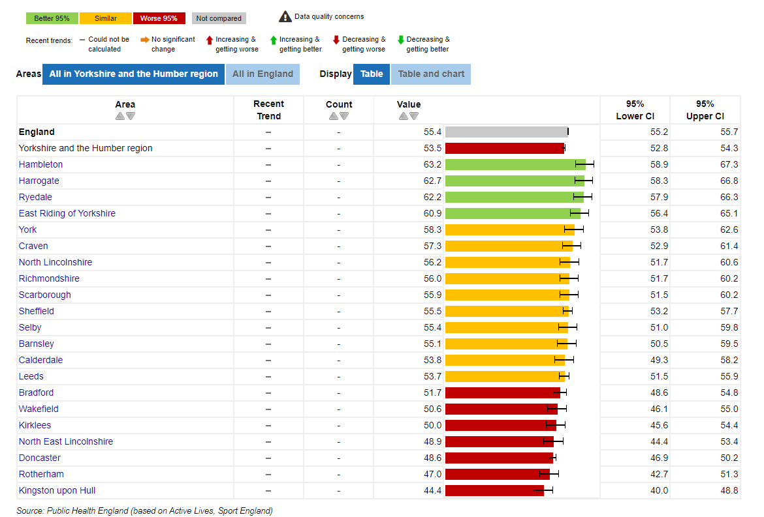

Public Health Profile: Utilisation of outdoor space for exercise/health reasons (Mar 2015-Feb 2016)

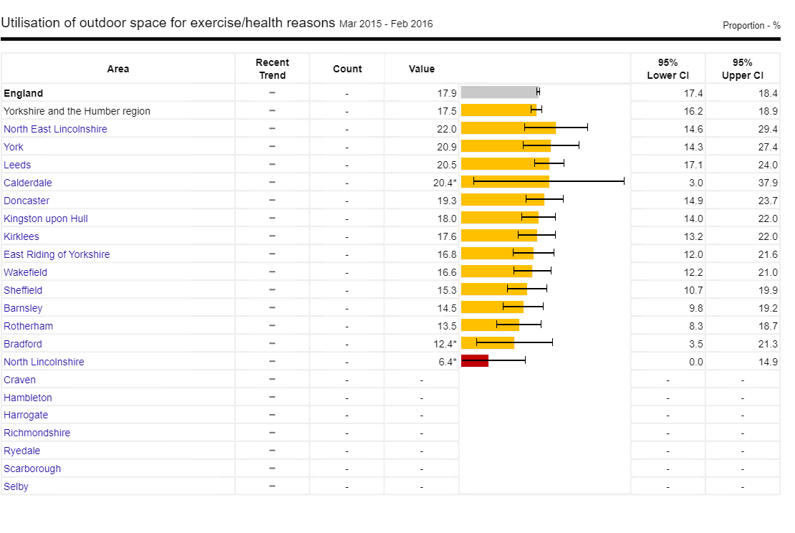

Public Health Outcomes Framework: B19 – Loneliness: Percentage of adults who feel lonely often /always or some of the time (2019/20)

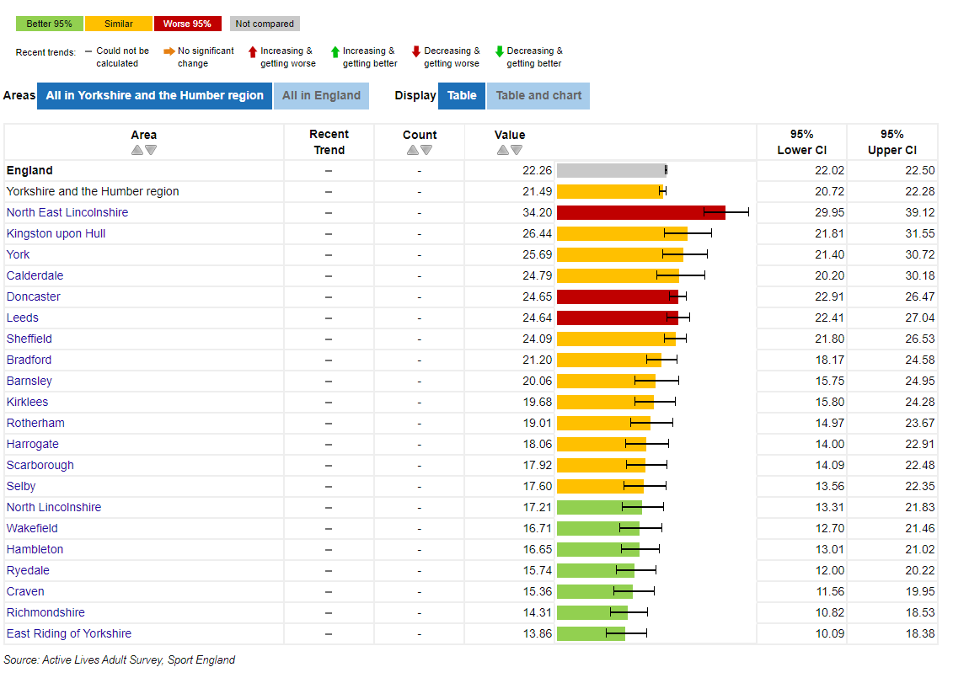

Resources and Further Information
Improving Access to Green Space: A New Review for 2020, Public Health England, 2020

NHS England's Healthy New Towns programme explores how the development of new places could create healthier and connected communities with integrated and high-quality services. One of the 10 Putting Health into Practice principles is focussed around inspiring and enabling healthy eating. The principle suggests local authorities set out requirements for food growing spaces when developing local planning policies. Working with local community groups, local authorities and developers can extend growing areas in new developments. They can make creative use of spaces in and around buildings, such as roofs, walls and balconies. Landscaping can include edible rather than ornamental plants. The community should be actively involved from the start.

Planning sustainable cities for community food growing, Sustain, 2014
This report sets the planning context in the four nations and provides the background to community food growing. The bulk of the report is structured around the different issues that food growing helps to address, from sustainability to residential amenity via health and wellbeing, green infrastructure, regeneration and many other agendas, Sustain 2014

Social Farms & Gardens is a UK wide charity supporting communities to farm, garden and grow together. Social Farms and Gardens have a community growing resource pack available to download from their website.

Which tool to use? Federation of City Farms & Community Gardens
A guide for evaluating health and wellbeing outcomes for community growing programmes.

Research and Evidence: Benefits of community growing, green spaces and outdoor education
Federation of City Farms & Community Gardens.

A Growing Health Toolkit - Garden Organic & Sustain, 2016
A community food grower’s guide to working with the health service.

Royal Horticulture Society – Set up a community garden
A list of things to consider when setting up a community garden, including information on insurance, fundraising and risk assessments.

Space for growing food: a guide
Guidance for community groups wanting to start a food growing project. Although the guidance is from 2012, it contains a lot of useful information that is still relevant.

Social Farms and Gardens and the Royal Horticultural Society both provide interactive maps that can be searched for local community growing groups registered with their organisations.

Some of the information and examples included in this action card were derived from discussions and presentations from the Healthier & Resilient Food Systems Network, with special thanks to Fran Hallsall & Sue Pearson (Sheffield) and Karen Thomas (Wakefield) who shared details of their local groups.

This action card is a live document and can be added to and amended as and when appropriate. If you are aware of any useful guidance or tools or local groups you would like to be included, please send details to Nicola.smith@dhsc.gov.uk

